Technology Supports for Students with Moderate to Severe Disabilities
in Inclusive Settings
Each image or word has a link to an online resource, ctrl + click to follow.

First, Let’s Presume Competence
Presuming competence is the first step to including students with moderate to severe disabilities (MSD) in general education classrooms for academic instruction.

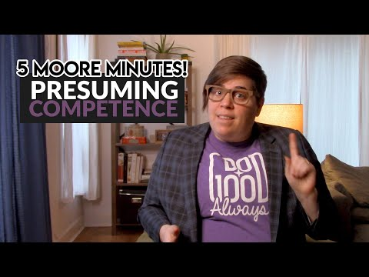

Watch Shelley Moore discuss the importance of presuming competence and the mind shifts necessary to begin effective inclusion.

Read this article about presuming competence for students in the U.S. and its impact on inclusive education.

General Supports
Explore the links for examples of support for ALL students in inclusive settings across content areas. Each image is linked to a website or article.

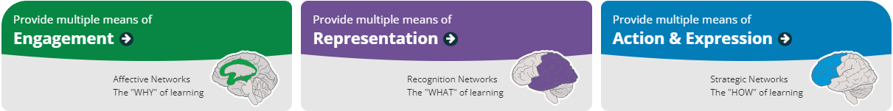
The Universal Design for Learning (UDL) framework was created for the improvement and optimization of teaching and learning of all people based on scientific human learning insights (CAST, 2018).

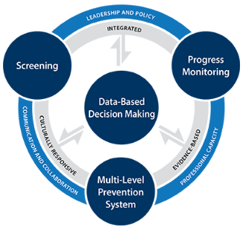
The Multi-Tiered System of Supports framework integrates data usage and instruction to be proactive and preventative while using a strengths-based perspective. Explore these resources for additional teaching support.

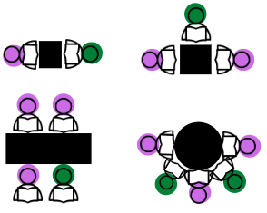
Consider the options for assistive technology for students with ID and how you can incorporate technology for all students in the inclusive setting. Read this article for a recent review of the literature. Explore peer support arrangements and determine how you can better incorporate these arrangements in inclusive settings.

Communication
All students should have a voice across settings. The TIES Center at the University of Minnesota offers a link to a free online course, TIES 101: Communication Supports in the Inclusive Class.

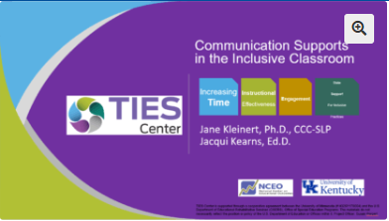

Read this article about communication partners to determine what skills communication partners need to support AAC users. See AAC infographic for more detailed information.

Reading/Language Arts
Explore these resources for reading/language arts skills.

Graphic organizers are tools that are flexible enough to use across academic content areas and all students (Reyes et al., 2020). Educators can collaborate to match materials and format organizers to meet individual student’s needs (Reyes et al., 2020). Access this website for interactive graphic organizers and this one for printable organizers. (Free)

Check out BookShare. This platform provides literary and non-fiction text at students' appropriate reading level. You may need an account through your school district.

This website provides reading passages online or to print with a range of reading levels, topics, and genres (Free). These passages can also be used for fluency or comprehension question data collection.
A fun interactive method to practice vocabulary and comprehension. (Free)

This website has vocabulary aligned to literary and non-fiction texts with options for games and practice (Free).

Writing:

Check out this blog post by Brookes Publishing. They offer seven steps for consideration when designing programs to teach written expression to students with disabilities.

Watch:
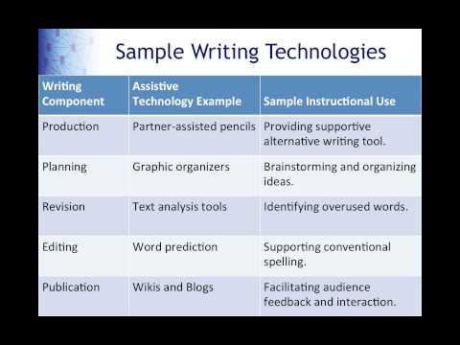
This video demonstrates alternate forms of writing. Remember pictures and symbols could also be used. Laptops, speech to text, spell checkers, word prediction, and much more provide students with an MSD many options to create a written piece of work for assignments.

Math
Read this article to learn how to make math accessible for all students.

Virtual manipulatives:
These can be used for in-person or virtual instruction. The many options for math manipulatives are useful for diverse learners across grade levels.

References

Ayers Institute for Learning & Innovation (2022). Holt interactive graphic organizers.
eduToolbox: Lipscomb University. https://www.edutoolbox.org/rasp/2181
Biklen, D. (2020). Presuming competence, belonging, and the promise of inclusion: The US
experience. Prospects, 49(3), 233-247. https://doi.org/10.1007/s11125-020-09510-0
Brookes Publishing Company (2022) Seven steps to teaching writing skills to students with
disabilities.
https://blog.brookespublishing.com/7-steps-to-teaching-writing-skills-to-students-with-disabilities/
Carter, E. E. (2022). A guide to implementing peer support arrangements. In E. E. Biggs & E.
Carter (Eds.), The Power of Peers. TIES Center. https://publications.ici.umn.edu/ties/peer-engagement/practice-guides/peer-support-arrangements
CAST (2018). Universal Design for Learning Guidelines version 2.2. Retrieved from
http://udlguidelines.cast.org
Center on Multi-Tiered System of Supports (n.d.) Essential components of MTSS. American
Institutes for Research (AIR). https://mtss4success.org/essential-components
Didax (2022). Virtual Manipulatives. https://www.didax.com/math/virtual-manipulatives.html
Dynamic Learning Maps (2014, January 11). Writing production and distribution (part 1).
https://www.youtube.com/watch?v=Sl3RPFWvpAY&t=215s
Fernández-Batanero, J.M., Montenegro-Rueda, M., Fernández-Cerero, J., & Garcia-Martinez, I.
(2022). Assistive technology for the inclusion of students with disabilities: a systematic review. Education Technology Research and Development.
https://doi.org/10.1007/s11423-022-10127-7

Mathigon (2022). Polypad. https://mathigon.org/polypad
Marlow, A. and Novak, K. (2022) Making math accessible for all students. Edutopia: George
Lucas Educational Foundation.
https://www.edutopia.org/article/making-math-accessible-all-students
Maryland Learning Links (2019). The Maryland assistive technology guide. Maryland State
Department of Education (MSDE).
https://www.marylandlearninglinks.org/the-maryland-assistive-technology-guide/
Moore, S. [Five Moore Minutes] (2021, February 1). The importance of presuming competence
[Video]. YouTube. https://www.youtube.com/watch?v=6Mq8sQTEhG8
Reyes, E. N., Wakeman, S., & Bowman, J. (2020). The Use of Graphic Organizers in Inclusive
Classrooms for Students with Significant Cognitive Disabilities (TIPS Series: Tip #10). Minneapolis, MN: University of Minnesota, TIES Center.

